Julian Kotara

In Praise of Shadows Response

Darkness and shadows are essential to understanding our surroundings, yet they are often frowned upon in Western architecture. Our obsession with the eradication of shadows leads to boring architectural choices and an over-reliance on electric lighting to satisfy our visual needs. In In Praise of Shadows, author Jun'ichirō Tanizaki speaks about his enjoyment of shadows in Japanese architecture, his experience in Japan’s westernization, and the subsequent over lighting of these spaces.
As one of his examples, Tanizaki speaks about the wonders of Japanese lacquerware and the necessity for it to be viewed in dark Japanese rooms. He writes, “But render pitch back the void in which [the lacquerware] stand, and light them not with the rays of the sun or electricity but rather a single lantern or candle: suddenly those garish objects turn somber, refined, dignified” (Tanizaki 13-14). Viewed outside or under the unwavering electric light, the lacquerware appears ugly and “garish” as its black color becomes too visible. Under the flickering candlelight, the dark lacquerware fades into its surroundings, leaving the specks of gold and silver to dance in the darkness. The lack of light creates a beautiful scenario in which the addition of light ruins beauty, implying that less is more. As Japanese culture grew up in shadowed houses, it tracks that the lacquerware and other household objects would be aesthetically designed for the flickering of the candlelight. As the West discovered electric light and heralded in the new technology to every street corner and house, we forgot about shadow and darkness as an element of life and our objects followed suit. Unfortunately, just as daylight needs the night, the Western silverware and household objects only existed in an over lit world and have lost their aesthetic appeal.
With the West’s obsession with light comes a need for decoration. Flatly lit walls in a suburban home cry out for decoration by paintings, photos, shelves, or plants. In Western houses, it is rare to see a wall continue for more than twenty feet without a decoration or object breaking up its simple monotony. This is unnecessary in Japanese houses where shadows and lights intermingle to create dynamic shapes and colors from surround room. Tanizaki writes, “And so, it has come to be that the beauty of a Japanese room depends on a variation of shadows, heavy shadows against light shadows – it has nothing else. Westerners are amazed at the simplicity of Japanese rooms, perceiving in them no more than ashen walls bereft of ornament. Their reaction is understandable, but it betrays a failure to comprehend the mystery of shadows” (Tanizaki 18). The understanding of shadow as a necessary compliment to light has been lost in America, leading to a misunderstanding by Westerners as to the simplicity of the rooms. When light itself is the decoration and dictator of aesthetics in space, superficial objects are not needed to hang on the walls and ceilings.
To Tanizaki’s sadness, the end of feudal Japan brought in the influence of Western lighting and aesthetics, making the use of shadows become less common in commercial buildings and residential homes: “Light is used not for reading or writing or sewing but for dispelling the shadows in the farthest corners, and this runs against the basic idea of the Japanese room. Something is salvaged when a person turns off the lights at home to save money, but at inns and restaurants there is inevitably too much light in the halls, on the stairs, in the doorway, the gate, the garden. The rooms and the water and stones outside become flat and shallow” (Tanizaki 38). The over lighting of these Japanese spaces destroys the depth and dynamics intentionally created by the architects to paint the house and its rooms throughout the day. Now in homes, lights are turned off to save money, and inns and restaurants keep theirs on the entice customers to their business and dispel any idea of darkness that might frighten patrons away.
Shadows and darkness provide a necessary compliment to light that creates dynamic and complicated scenes where depth and intrigue can be understood. Without shadow, there is only light, and the understanding of depth and materiality is stripped away from any creation.

It is often difficult to find modern examples, especially homes, where shadows and darkness are used in architecture. The Trestle Cabin designed by Miller Hull Partnership employs daylighting and wooden materials to create an ecofriendly cabin nestled in the woods of Decatur Island in Washington State. The black exterior walls hide away the suspended structure from the hillside, rejecting light and reducing its visual impact on the land. Large overhands create coverage for the separate sleeping quarters and living space, shielding large glass windows from direct sun during most times of the year. Warm wood decking leads into a completely wooden interior, where minimal electric lighting is used in task specific spaces like the kitchen. Windows on all sides of the building create let ample daylight into the warm space, where it can interreflection enough to makes usable during the day without addition lighting. This creates an atmosphere where shadows are welcome to collect in the corners of the room on cloudy days or streak across the floor on a sunny day, interacting with the wood paneling to highlight distinct characteristics. In Image 1 of the master bedroom, dappled light from the tree hits an area on the floor, interacting with different hues in the wood wonderfully.

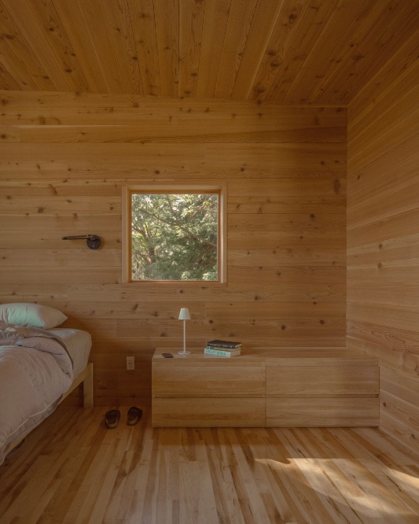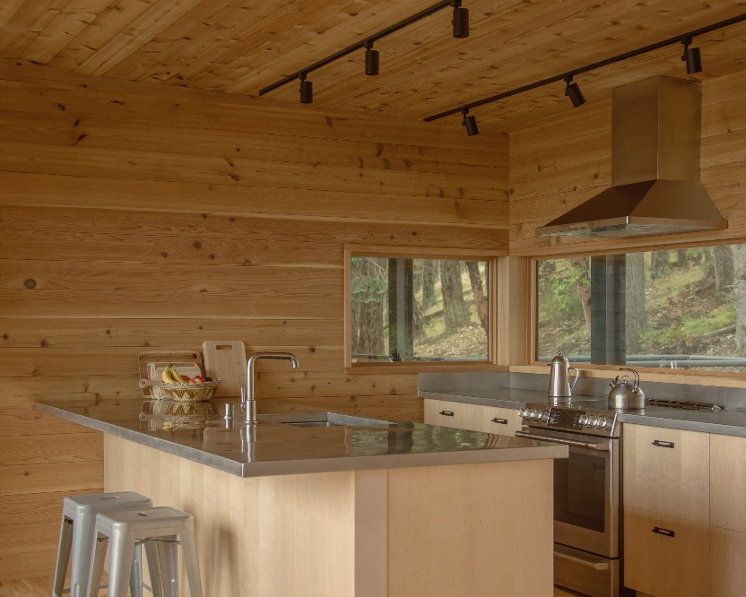
Image 1: Master Bedroom Image 2: Kitchen and Counter

It is unfortunate that few photos of space exist during direct sunlight as the contrast between light and dark would be much more pronounced and the harsh shadows would likely layer onto softer shadows as the day passes. The use of wood for a majority of surfaces connects the building with nature and the natural world. Tanizaki praises the wood and mat bathrooms common Japan for their understanding of our “dirty” nature. Similarly, this cabin nestled into the forest hillside accepts the dirt and natural materials surrounding it that will likely be tracked in by the inhabitants with open arms, rather than sterile, smooth flooring. The effect of combining the natural patterns of light with the natural environment connects to Tanizaki’s praise of shadow and connection to nature in a modern and sustainable method.

Growing up, I think I had more connections to light and shadow than the average kid. With both my parents working in graphic design; my father, a professional artist, and my mom enjoying black and white film photography, there were always little teaching moments about how light and shadow created composition and affected color perception. My father’s studio has four skylights on the north roof which often cast long shadows down the walls. Harsh lines of light often fell across his art on the walls, but during later times of the day, a dappled light from the trees above gave his art new life and dynamics. Both effects sometimes made it into his artwork through the tracing of shadow lines or through color matching across these high contrast gradients. As a small child growing up in this space, I grew appreciative of the natural lighting effects that were created and began to understand how light and shadow worked from a young age. This was further grown through my dad’s interest in sculpture and architecture; odd forms that captured, reflected, and blocked light at different times of the day creating magnificent shapes and effects separate from the object itself. A classic example is our porch chairs, old wooden chairs with a swirling handle that reveals music clef-like shapes on the ground that lengthen as the evening continues. My understanding of an object’s forms and ability to cast shadows onto different surfaces grew and I gained an appreciation for these effects that I still enjoy finding today. A book titled The Shadows Around Us would illustrate this concept through images like the following:

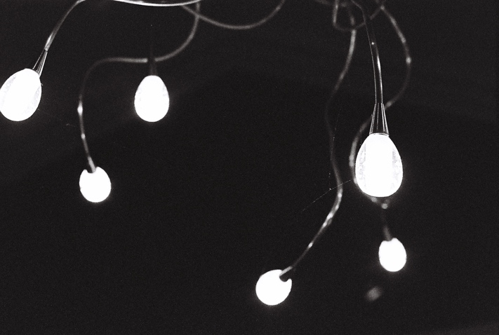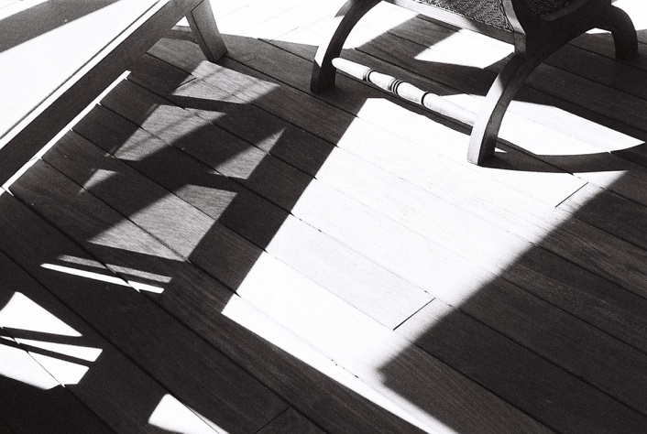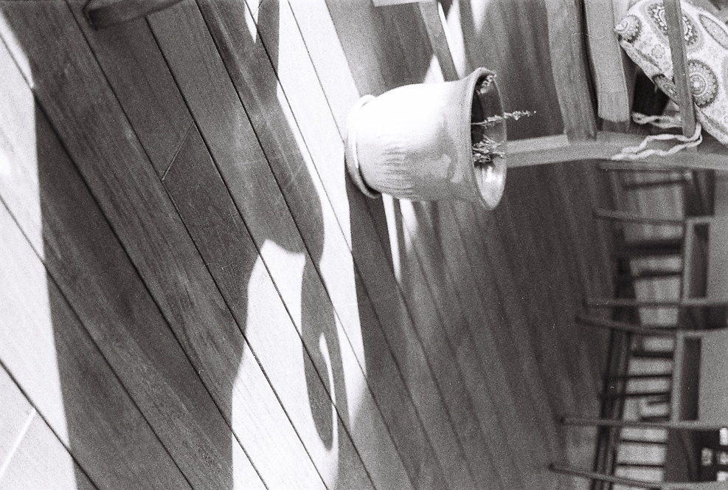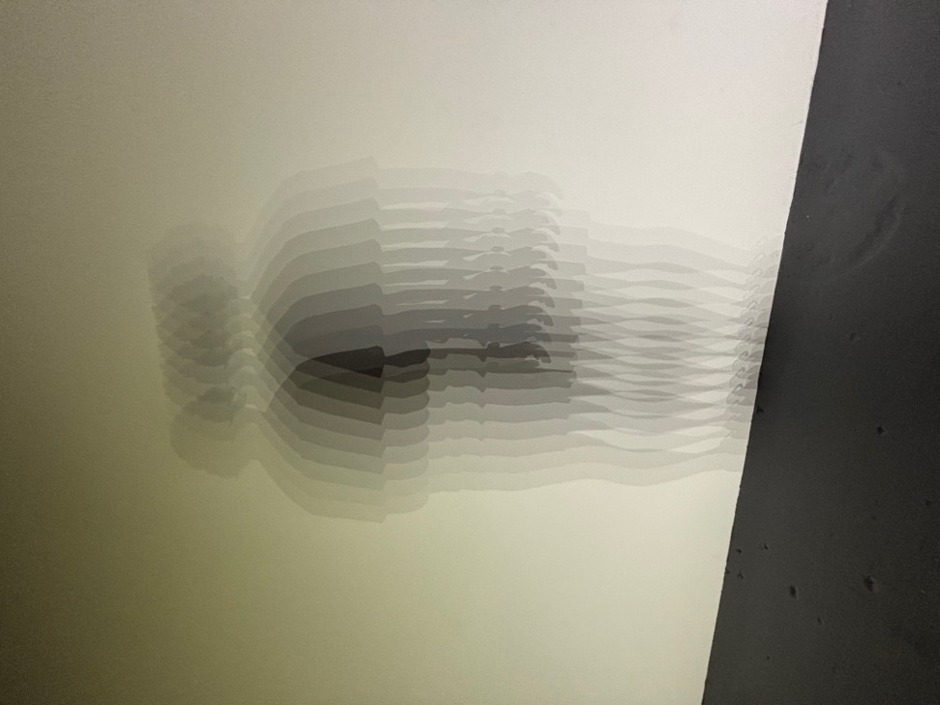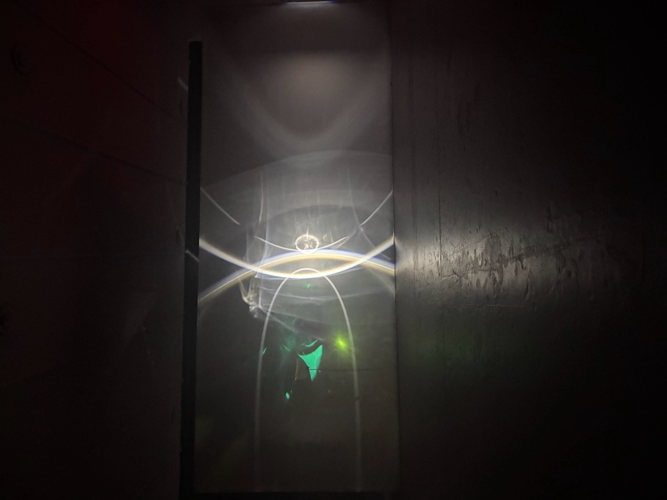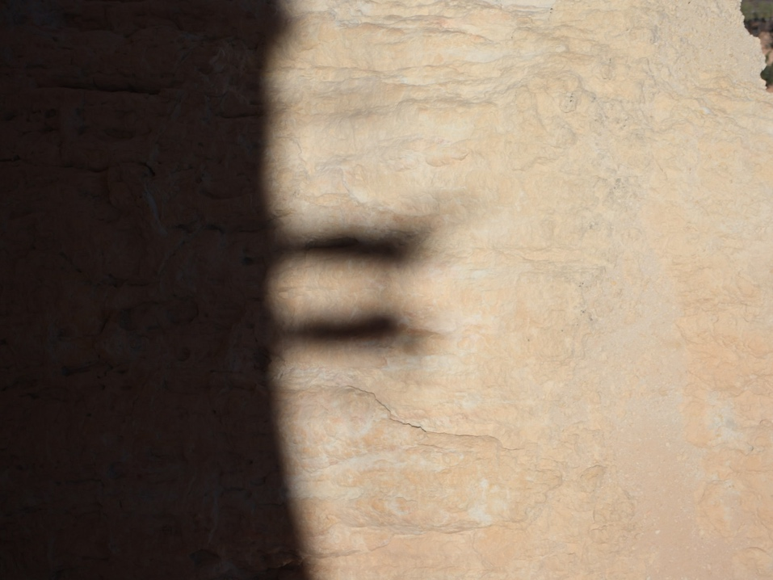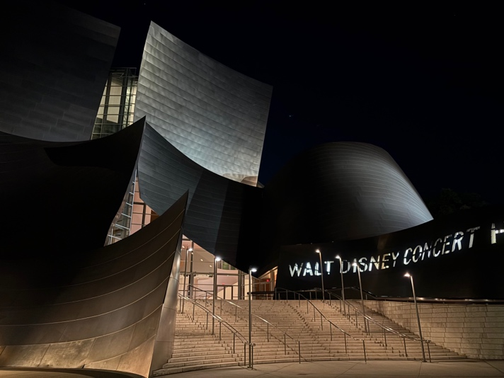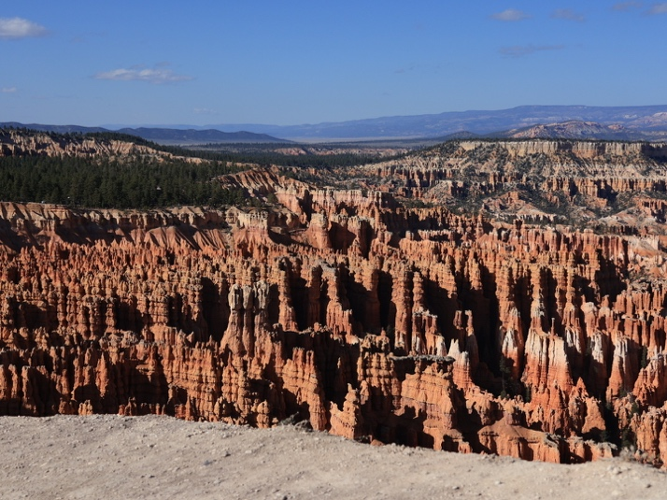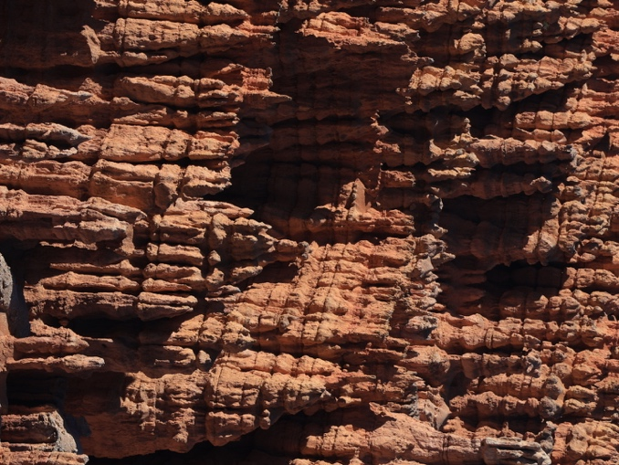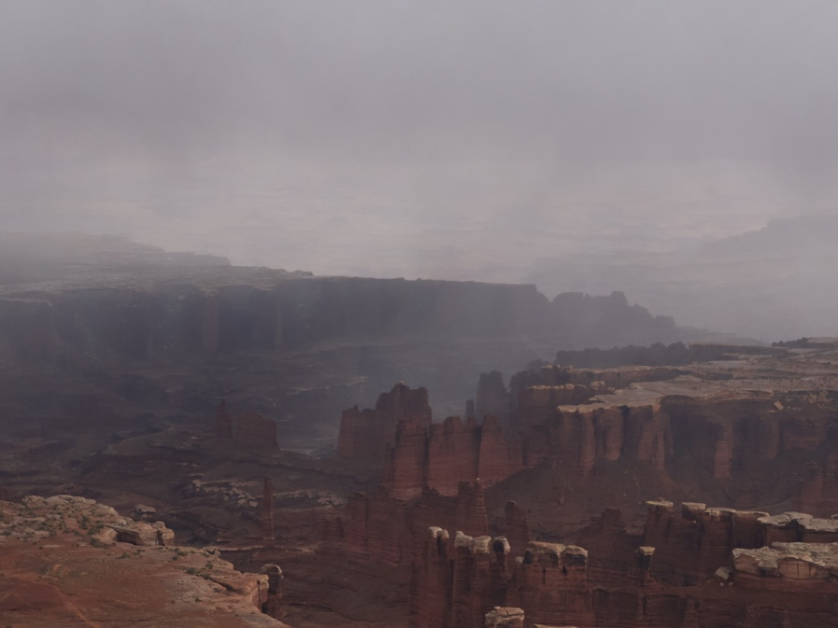

Sources:
https://www.dezeen.com/2025/09/08/miller-hull-partnership-trestle-cabin-washington/
https://www.archdaily.com/1030999/trestle-cabin-miller-hull-partnership?ad_source=search&ad_medium=projects_tab
Images by Julian Kotara

